Running head: ATTENTION TO ASSOCIATIVE AND SEMANTIC KNOWLEDGE

UPDATE THE VERSION # and DATE FOR EACH REVISION
VERSION 05 – 04/13/2009

The Priority of Associations:
Differential Attention to Associative and Semantic Knowledge during Memory Judgments

William S. Maki
University of Arizona, Tucson, AZ
Erin Buchanan
University of Mississippi, University, MS

Correspondence: William S. Maki
2785 East Posse Court
Green Valley, AZ 85614
Phone: 520 232 3117
Email: wmaki@email.arizona.edu

Abstract
Participants judged pairs of words on the basis of associative or semantic similarity. Associative judgments were not affected by semantic similarity, but semantic judgments were affected by both associative and semantic information. Apparently, semantic information was available but ignored when making associative judgments while associative information cannot be overlooked. This effect was independent of specific measures of semantic, associative and thematic similarity and instructional effects. These results suggest that there is an attentional separability between associative and semantic information even when word pairs contain both relationships. It is suggested that associative relationships have priority over semantic relationships because they consistently predict both semantic and associative judgments of similarity.

The Priority of Associations:
Differential Attention to Associative and Semantic Knowledge during Memory Judgments

The relation between associative and semantic knowledge has been the subject of speculation for over a century of experimental psychology. In the 1880s, Trautscholdt distinguished between “outer” associations acquired through frequent environmental co-occurrence and “inner” associations, which included various semantic relationships (Esper, 1973). In modern times, a similar distinction was made by Collins and Loftus (1975) between a lexical network and a semantic network; spreading activation within the semantic network was seen to be the source of semantic facilitation or priming. Fodor (1983) later explicitly localized associative information in the lexical network and allowed a spread of activation among lexical nodes. Although different in particulars, analogous separations of lexical and associative knowledge on one hand and semantic knowledge on the other persist in parallel distributed and interactive activation models of memory (Masson, 1995; Moss, Hare, Day, & Tyler, 1994; Plaut, 1995; Stolz & Besner, 1999).
Associative and semantic relationships among pairs of words have typically been investigated using production techniques. Perhaps the oldest and best-known technique is that of free association (Galton, 1879; Nelson, McEvoy, & Schreiber, 2004). In the free association test, people are presented with a list of cue words and are asked to produce the first word that comes to mind in response to each cue. Averaged over many participants, the probability of a response word given a cue is taken as an index of associative strength. Semantic relations have been assessed by the similar technique of semantic feature production (McCrae, Cree, Seidenberg, & McNorgan, 2005; Vinson & Vigliocco, 2008). In this task, people are asked to produce a list of features that characterize some target concept. Semantic similarity is measured by the extent to which two such lists of semantic features overlap when aggregated over many participants; the cosine is a common measure. Lexicographers perform a similar task when they list defining features of concepts in dictionary definitions.
An alternative way of measuring degree of association and semantic similarity is to have people make judgments about given pairs of words. These methods employing rating scales were explored many years ago (Garskof & Forester, 1966; Haagen, 1949). More recently judgments have been used to measure associative and semantic similarity (Miller & Charles, 1991; Nelson, Dyrdal, & Goodmon, 2005). Associative judgments have been used as a model system for measuring and counteracting cognitive biases (Koriat, Fiedler, & Bjork, 2006). And, associative judgments have been investigated as a topic of experimental and theoretical interest in its own right (Maki, 2007a, 2007b). The latter line of research, focusing on the relationship between free association probabilities and associative judgments, led to some discoveries that motivated the research reported here.
In previous experiments using a memory judgment task, people rated pairs of words based on the degree of association (Maki, 2007a, 2007b). College students were asked to assign a number to each cue-response pair that indicated how many people out of 100 would be likely to give the response word when prompted with the cue word in a free association task. Maki (2007a) plotted the average values of the judgments of associative memory (JAM) as a function of forward associative strength (FSG; Nelson et al., 2004). The resulting “JAM function” was perfectly linear with a shallow slope and a high intercept. Of interest here is the fact that the JAM function was completely insensitive to semantic distance between words. For example, the word pairs used by Maki (2007b, Experiment 1 transfer phase) varied along both associative and semantic dimensions. Semantic distance was defined as distance between nodes in a hierarchically organized electronic dictionary, WordNet (Fellbaum, 1998). Distance was computed by Maki, McKinley, and Thompson (2004) using the scripts developed by Patwardhan & Pedersen (2003) to calculate the distance measure devised by Jiang and Conrath (“JCN”; 1997). The word pairs were selected on the basis of the JCN values so as to fall into two distinct categories, high similarity (low JCN distance, M = 1.9, range: 0-4.6) and low similarity (high JCN distance, M= 21.7, range: 20.2-24.5). In spite of the extreme difference between semantic distance categories (a factor of over 10), semantic distance had absolutely no effect on associative judgments. For high similarity pairs, JAM = 48.7 + 28.4 FSG, R² = 0.996; for low similarity pairs, JAM = 49.1 + 27.0 FSG, R² = 0.948.
One interpretation of these results is that people are able to attend selectively to associative information to the complete exclusion of semantic information. An important next question is whether the reverse holds true: can attention be directed to semantic information at the expense of processing associative information? Research on measures of semantic similarity suggest otherwise. Maki et al. (2004) had people rate the semantic similarity of pairs that differed both in dictionary distance (JCN) and associative strength (FSG). Both semantic and associative dimensions significantly influenced similarity ratings. So it appears that attention can be directed selectively to associative information but associative information cannot be completely ignored when judging semantic similarity. If that is so, then current conceptions of the representation and use of associative and semantic information may need to be revised. If associative and semantic information are separate, then why do associations influence semantic similarity ratings? If semantics reduce to associations (as in Deese, 1965), then how is it possible to attend to some associations and ignore others? We will offer an answer to these questions at the close of this paper. Before doing so, we need to establish the reliability of the asymmetrical selection effect described above.
The evidence presented thus far needs to be viewed cautiously. The problem is that the comparisons between associative and semantic judgment studies (Maki, 2007b vs. Maki et al., 2004) are confounded by different groups of words, different judgment procedures, and anything else that might contaminate cross-experiment comparisons. Thus, the experiment described in this report was designed to eliminate those confounds and thereby provide more solid evidence for the phenomenon of asymmetrical selection of associative and semantic information. A second aim was to generalize the asymmetrical selection effect to another measure of semantic similarity. People rated pairs of words either on the basis of degree of association or on the basis of semantic feature overlap. Both kinds of judgments were made on a common list of word pairs using rating scales that differed only in the instructions distinguishing associative from semantic ratings.
Method
Materials
A sample of 72 pairs of words was drawn from the Nelson et al. (2004) word association norms. The words in the selected pairs also appeared in the McRae et al. (2005) semantic feature production norms; the pairs all had similarities (cosines) greater than zero. No duplicates were permitted so each of the 144 words was unique. When selecting the pairs, our focus was on finding pairs such that both the associative strengths (FSG) and the semantic similarities (COS) of the pairs were distributed across the full range of values insofar as possible. Figure 1 is a scatterplot of both variables’ values for each of the 72 pairs. For a given level of one variable, Figure 1 shows substantial variation along the other variable.
Other properties of the words were not controlled. However, we computed the descriptive statistics for six other variables: the natural logarithms of cue (Log QFR) and target frequencies (Log TFR; Nelson et al., 2004), the numbers of associates (set sizes) for each cue word (QSS) and target word (TSS; Nelson et al., 2004), similarity scores (LSA cosine) from latent semantic analysis (Landauer & Dumais, 1997), and the composite measure computed using BEAGLE (BGL; bound encoding of the aggregate language environment; Jones & Mewhort, 2007). The summary statistics for all these measures are given in Table 1. The uncontrolled variables showed substantial variation. For example, the means and ranges of the two similarity variables, LSA and BGL, are about the same as those for the main predictor variables, FSG and COS.
With respect to our main two variables, FSG and COS, each of the pairs fell within one of four categories: x < 0.2, 0.2 < x < 0.4, 0.4 < x < 0.6, and x > 0.6. For FSG, the numbers of pairs within each category were 18, 14, 20, and 20, respectively. For COS, the numbers of pairs were 22, 21, 13, and 16, respectively. The 72 pairs were randomly ordered; both associative and semantic values from each category were represented about equally often in each half of the resulting list.
Two types of general instructions, associative and semantic, were prepared. The associative instructions were identical to those used by Maki (2007a). The instructions described a free association test and contained a demonstration of the free association procedure using the same three cue words used by Maki (2007a). The semantic instructions were identical to those used by Maki, Krimsky, and Munoz (2006). Those instructions emphasized semantic feature overlap as a means of judging semantic similarity and contained a demonstration of semantic similarity ratings using three pairs that were not included in the 72 to-be-rated pairs. Four booklets were prepared. The instructions and demonstrations were printed on the first two pages of each booklet. Each of the remaining three pages was headed by a short paragraph with a reminder about the rating scale to be used followed by the scale itself. For the associative booklets, the reminder was: “Assume 100 college students from around the nation gave responses to each cue word. How many of these 100 students do you think would have given the response word?” The immediately following scale contained 10 categories (0 – 9) corresponding to estimated response frequencies of 0-9, 10-19, …, and 90-100. For the semantic booklets, the reminder was: “Imagine the defining features of both words in each pair and then rate the degree to which the words share those features.” The following scale also contained 10 categories (0-9) anchored by “No overlap (different meaning)” and “Complete overlap (same meaning).” The word pairs were listed following the scales on each page. Half the associative booklets and half the semantic booklets contained the original ordering of the 72 pairs; the remaining booklets contained the pairs in reverse order.
Procedure
Participants were tested in small groups, each containing 3-6 students. Each group was randomly assigned to receive either the associative or semantic instructions. Each participant was randomly assigned to receive a booklet containing either the original or reverse ordering of the 72 pairs. At the beginning of each group session, the participants read the general instructions. Then the experimenter reviewed the instructions and led the participants through the demonstration. At the end of the demonstration, the participants revealed their answers by a show of hands and discussed how the answers showed the type of relationship described in their booklets. Then the participants used the scales to rate the 72 pairs of words. Answers were marked on optical scanning forms.
Participants
Fifty-seven undergraduate college students (39 female) were recruited from the Texas Tech University Department of Psychology human subject pool and were compensated for their service by course credit. The random assignment of participants and groups resulted in 31 participants in the associative condition and 26 in the semantic condition.
Results
Associative and semantic ratings were averaged across participants for each of the 72 pairs and were entered into multiple regression analyses, one analysis for the associative instructions and a separate analysis for the semantic instructions. For both of the analyses, the predictor variables were associative strength (FSG), semantic feature overlap (COS), and the six uncontrolled variables listed in Table 1 (LSA, BGL, log QFR, log TFR, QSS, TSS). For the associative analysis, the dependent variable was the associative rating and, for the semantic analysis, the dependent variable was the overlap rating. The standardized regression coefficients (β weights) in these analyses reflect the degree of behavioral control exerted by the predictor variables.
In the stepwise regression analysis for the associative instructions FSG was identified as the only significant predictor of associative ratings (JAM), β = + 0.65, t = 7.03, p< .001. None of the other variables significantly predicted the ratings, largest other β = 0.14. Of special interest, the coefficient for the semantic predictor, COS, was not reliable, β = -0.08. This single predictor model accounted for 42.1% of the variance in the ratings; all the remaining variables together accounted for 2.6%. A different model was discovered for the semantic instructions in which both COS and FSG were significant predictors, β = + 0.53, t = 5.59, p< .001, and β = + 0.29, t = 3.10, p< .01, respectively. None of the other variables significantly predicted the ratings, largest other β = 0.16. This 2-predictor model accounted for 46.3% of the variance in semantic ratings; all the other variables combined accounted for 5.8%. For illustrative purposes, the β values for the two main predictor variables, FSG and COS, are shown in the left panel of Figure 2 for both instructional conditions. The pattern of results indicates that the associative variable, FSG, exclusively controlled associative ratings, but that both semantic and associative variables, COS and FSG, controlled semantic ratings. Thus this pattern of results confirms the previous findings described in the Introduction (Maki, 2007a, 2007b vs. Maki et al., 2004).
Additional evidence for the asymmetrical selection effect comes from a retrospective analysis of data reported by Maki (2007b, Experiment 1) that was performed after the present experiment was completed. Two groups of participants rated a common set of 90 pairs of words for either their associative or semantic relatedness. The “associative-varied” group received instructions similar to the associative group in this experiment. The “semantic-varied” group received instructions emphasizing semantic similarity. The 90 pairs varied considerably in associative strength (FSG) and also varied in semantic similarity (dictionary distance measured by JCN). The results of the regression analyses are shown in the right panel of Figure 2. Once again, the associative ratings were predicted only by associative strength but the semantic ratings were predicted by both associative strength and semantic similarity. The associative predictor (again FSG) accounted for significant variance in the associative ratings, β = + 0.54, t = 5.79, p< .001, but the semantic variable (JCN) was not a significant predictor, β = - 0.11, t = 1.20. For the semantic ratings, however, JCN was a significant predictor β = 0.36, t = 3.75, p< .001, and so was FSG, β = + 0.23, t = 2.42, p< .02. Thus the patterns of results in both the present experiment and the retrospective analysis were identical. The identical patterns show that the asymmetrical selection effect generalizes across type of semantic measure – feature overlap (COS) and dictionary distance (JCN).
Discussion
The present results indicate that there are differential effects of making associative and semantic judgments. The word pairs in this experiment were created so that the pairs could be judged on either associative or semantic information; both types of information were present in both judgment conditions. However, it appears that participants used semantic information only if given semantic instructions. Participants apparently were able to ignore semantic information while making associative judgments. In contrast, associative information was always used when making judgments regardless of the type of instructions. In addition, the differential selection of associative and semantic knowledge generalizes across measures; semantic feature overlap was the measure used in this experiment but dictionary distance was the measure used in earlier experiments that showed the same asymmetrical selection of associative and semantic information. We are thus led to conclude that associations have a privileged status when making memory judgments.
Before proceeding with the interpretation of the asymmetrical selection effect, we discount four alternative explanations for our results. First, the performance of our participants on our rating tasks is typical of what has been previously reported. The regression equation relating judgments of association to forward associative strength (“JAM function”) in this study was JAM = 52 + 37 FSG; in previous studies, the average regression equation was JAM = 50 + 36 FSG. (Maki, 2007b). Thus, our participants’ performances are not exceptional for these kinds of judgment studies.
Second, the asymmetrical selection effect is not specific to the feature overlap measure (COS) of semantic similarity. A re-analysis of data reported by Maki (2007b) showed that the effect is also found using a dictionary distance measure (JCN). As shown in Figure 2, both measures show exclusive control of associative ratings by associative information and show shared control of semantic ratings by associative and semantic informatino.
Third, one might ask about the influence of other properties of words and other measures of relations among words that were not controlled. We included six such measures in the regression analyses. The four item level variables, cue and target word frequency and set size, did not significantly contribute to explaining variance in either associative or semantic ratings. The other two measures were derived from statistical analyses of text, LSA (Landauer & Dumais, 1997) and BGL (Jones & Mewhort, 2007). These variables also were eliminated from the regression analyses. Maki and Buchanan (2008) performed multidimensional scaling (and other multivariate analyses) of associative variables (like FSG), semantic variables (like COS and JCN), and text-based variables (like LSA and BGL). The associative, semantic, and text-based variables tended to fall into three distinct clusters. Thus LSA and BGL represent something more than (or other than) what is tapped by the semantic production measures COS and JCN. The present results go further by dissociating the text-based measures from human judgments of association and semantic similarity.
Fourth, one might observe that associative and semantic instructions were confounded with point of reference. We were careful to follow exactly the instructions for associative judgments (Maki, 2007a) and for feature overlap ratings (Maki et al., 2006). But those instructions differed in point of reference; the associative instructions asked about what other students would do but the semantic instructions asked what the participant him- or her-self would do. When we have presented associative memory judgment data to various audiences in the past, we have occasionally been asked about the effect of the participant’s point of reference. The argument is that our associative instructions emphasize judgments of what other students would do and that participants are less able to make those judgments than if the instructions had focused on self reference. In response, Maki (2007b) reported results from two associative judgment experiments in which instructions were manipulated. For the “other” instructions, the slope of the JAM function was 34, and for the “self” instructions, the slope of the JAM function was 22. Both slopes are within the range of those found in previous studies (Maki, 2007a, 2007b). Thus focusing on what the participant (self) would do did not improve associative judgment accuracy. The shallower slope in the self condition shows that, if anything, the “self” instructions produced less accurate judgments than did the “other” instructions.
Another approach to dealing with this issue is to hold instructions constant. The semantic judgment instructions in the present study copied those used by Maki et al. (2006); both sets of instructions emphasized the “self” point of reference. For present purposes, we reanalyzed the Maki et al. data. We extracted (from their Study 2) 34 pairs of words that varied considerably in degree of feature overlap (COS). The individual words appeared in the association norms (Nelson et al., 2004) but the pairs did not; thus for practical purposes, the pairs were not associatively related (FSG = 0) and thus there was no associative variation. The regression line relating semantic similarity judgments to normed feature overlap was SIM = 0.69 + 81.7 COS, R² = 0.816 (β = 0.903). In contrast, the regression line obtained in the present study in which there was substantial associative variation was SIM= 35.2 + 20.0 FSG + 36.7 COS, R² = 0.463. So what seems important is the presence or absence of associative relationships and the degree of associative variation even when instructions are held constant. Participants appear to be unable to filter out associations when judging semantic similarity with the result that the associative relations compete with semantic relations for control of judgments.
The regression equations predicting rated feature overlap (SIM) from the normed COS values are important for another reason. In the absence of competing associations, the intercept is nearly zero indicating no overall inflation of the ratings. In fact, forcing the intercept to zero changes the slope slightly (82.9) and the proportion of explained variance changes hardly at all (0.8156). This means that the participants in the Maki et al. (2006) study were showing nearly perfect calibration of their semantic ratings. In previous studies of associative ratings (Koriat et al., 2006; Maki, 2007a, 2007b), in contrast, there was a strong bias effect (intercept ~ 50) that proved impervious to many attempts to reduce it. Such biases are noted in many other domains. For example, people overestimate their own abilities (Dunning, Johnson, Ehrlinger, & Kruger, 2003). However, the present analysis limits the generality of such biases. At least in the domain of judgments about verbal materials, inflationary bias is not inevitable. The bias appears to arise when selectively attention to semantic information fails in the face of competing associative information. Whether this analysis applies to instances of inflated judgments in other domains remains to be seen.
What then is the basis for the asymmetrical selection effect? Here we propose a possible explanation in the form of a model for associative and semantic judgments. Suppose that the knowledge underlying all our similarity ratings takes the form of a vast network in which any given node is linked to many other nodes. Each such link has a strength that derives from physical or linguistic experience. Some “associative” links connect nodes representing frequently co-occurring words. Other “semantic” links connect nodes representing words to nodes representing the defining features of the word’s referent concept. Given two words for an associative judgment, A and B, only two links need be evaluated: A→B and B→A. But given the same pair for a feature overlap judgment, the links from A need be generated, the links from B need be generated, the resulting activated nodes need be compared, and the strengths for the surviving links need to be computed. The semantic judgment process thus is far more complex than is the associative judgment process. Moreover, the semantic judgment process includes the “associative” links connecting A and B. Because the associative judgment process does not involve any semantic feature links, judgments are based purely on associative information. Because the semantic judgment process includes all links involving A and B, associative links are considered along with semantic feature links so semantic similarity judgments are influenced by associative information as well as semantic information.
To sum up, during a memory judgment task, attending to associative information completely blocks control of judgments by semantic information, but attending to semantic information fails to block control by associative information. The results of the present experiment, together with previously noted findings (Maki, 2007a, 2007b; Maki et al., 2004), demonstrate the reliability and generality of this asymmetry; the differential selection has been found with different materials and measures. Taken as a whole, our results show that associative information takes priority over semantic information. Associations can be selectively attended but not ignored when making similarity judgments. Ultimately, the phenomenon of differential selection of associative and semantic knowledge must figure into our understanding of what people know about their associative and semantic memories and how they know it.

References
Collins, A. M., & Loftus, E. F. (1975). A spreading-activation theory of semantic processing. Psychological Review.,82, 407-428.
Deese, J. (1965). The structure of associations in language and thought. Baltimore, MD: Johns Hopkins University Press.
Dunning, D., Johnson, K., Ehrlinger, J., & Kruger, J. (2003). Why people fail to recognize their own incompetence. Current Directions in Psychological Science, 12, 83-87.
Esper, E. A. (1973). Analogy and Association in Linguistics and Psychology. Athens, GA: University of Georgia Press.
Fellbaum, C. (Ed.). (1998). WordNet: An Electronic Lexical Database. Cambridge, MA: The MIT Press. http://www.cogsci.princeton.edu/~wn
Fodor, J. A. (1983). The Modularity of Mind: An Essay on Faculty Psychology. Cambridge, MA: The MIT Press.
Galton, F. (1879). Psychometric experiments. Brain, 2, 149-162.
Garksof, B. E., & Forester, W. (1966). The relationships between judged similarity, judged association, and normative association. Psychonomic Science, 6, 503-504.
Haagen, C. H. (1949). Synonymity, vividness, familiarity, and association value ratings of 400 pairs of common adjectives. The Journal of Psychology, 27, 453-463.
Jiang, J. J., & Conrath, D. W. (1997). Semantic similarity based on corpus statistics and lexical taxonomy. In Proceedings of International Conference Research on Computational Linguistics (ROCLING X), Taiwan.
Jones, M. N., & Mewhort, D. J. K. (2007). Representing word meaning and order information in a composite holographic lexicon. Psychological Review, 114, 1-37.
Koriat, A., Fiedler, K., & Bjork, R. A. (2006). Inflation of conditional predictions. Journal of Experimental Psychology: General, 135, 429-447.
Landauer, T. K., & Dumais, S. T. (1997). A solution to Plato’s problem: The latent semantic analysis theory of acquisition, induction, and representation of knowledge. Psychological Review, 104, 211-240.
Maki, W. S. (2007a). Judgments of associative memory. Cognitive Psychology, 54, 319-353.
Maki, W. S., (2007b). Separating bias and sensitivity in judgments of associative memory. Journal of Experimental Psychology: Learning, Memory, and Cognition, 33, 231-237.
Maki, W. S., & Buchanan, E. (2008). Latent structure in measures of associative, semantic, and thematic knowledge. Psychonomic Bulletin & Review, 15, 598-603.
Maki, W. S., Krimsky, M., & Muñoz, S. (2006). An efficient method for estimating semantic similarity based on feature overlap: Reliability and validity of semantic feature ratings. Behavior Research Methods, 38, 153-157.
Maki, W. S., McKinley, L. N., & Thompson, A. G. (2004). Semantic distance norms computed from an electronic dictionary (WordNet). Behavior Research Methods, Instruments, & Computers, 36, 421-431.
Masson, M., E., J. (1995). A distributed memory model of semantic priming. Journal of Experimental Psychology: Learning, Memory, and Cognition, 21, 3-23.
McRae, K., Cree, G. S., Seidenberg, M. S., & McNorgan, C. (2005). Semantic feature production norms for a large set of living and nonliving things. Behavior Research Methods, 37, 547-559.
Miller, G. A., & Charles, W. G. (1991). Contextual correlates of semantic similarity. Language and Cognitive Processes, 6, 1-28.
Moss, H. E., Hare, M. L., Day, P., &Tyler, L. K. (1994).A distributed memory model of the associative boost in semantic priming. Connection Science, 6, 413-427.
Nelson, D. L., Dyrdal, G. M., & Goodmon, L.B. (2005). What is pre-existing strength? Predicting free association probabilities, similarity ratings, and cued recall probabilities. Psychonomic Bulletin & Review, 12, 711-719.
Nelson, D. L., McEvoy, C. L., & Schreiber, T. A. (2004). The University of South Florida free association, rhyme, and word fragment norms. Behavior Research Methods, Instruments, & Computers, 36, 402-407.
Patwardhan, S., & Pedersen, T. (2003), WordNet::Similarity. http://search.cpan.org/dist/WordNet-Similarity/
Plaut, D. C. (1995). Semantic and associative priming in a distributed attractor network. Proceedings of the 17th Annual Conference of the Cognitive Science Society (pp. 37-42). Hillsdale, NJ: Lawrence Erlbaum Associates.
Stolz, J. A., & Besner, D. (1999). On the myth of automatic semantic activation in reading. Current Directions in Psychological Science, 8, 61-65.
Vinson, D., & Vigliocco, G. (2008). Semantic feature production norms for a large set of objects and events. Behavior Research Methods, 40, 183-190.
Author note
Address correspondence to William S. Maki, 2785 East Posse Court, Green Valley, AZ 85614 (email: wmaki@email.arizona.edu).
Acknowledgments
We thank Ruth Maki, Kenneth Malmberg, and three anonymous reviewers for comments on an earlier version of this paper. These experiments were summarized in a poster presented at the Psychonomic Society meeting, Long Beach, November 2007, and at the University of South Florida Festschrift for Douglas L. Nelson, March, 2008.

Table 1. Summary statistics for each predictor variable in the experiment.

 | Mean | Minimum | Maximum
FSG | 0.365 | 0.014 | 0.846
COS | 0.450 | 0.009 | 0.879
Log QFR | 2.075 | 0 | 5.293
Log TFR | 2.887 | 0 | 6.384
QSS | 10.96 | 2 | 25
TSS | 15.50 | 3 | 29
LSA | 0.441 | -0.020 | 0.880
BGL | 0.414 | 0.078 | 0.839

Note. The means are averages over 72 cue-target pairs. The measures are: FSG (forward associative strength), COS (cosine measure of semantic feature overlap), QFR (cue word frequency), TFR (target word frequency), QSS (cue set size), TSS (target set size), LSA (cosine from latent semantic analysis), and BGL (the composite measure from the BEAGLE model).
Figure captions
Figure 1. Scatterplot of forward associative strength (FSG) and semantic feature overlap (COS) values for each pair of words.
Figure 2. Associative and semantic influences on judgments as a function of type of instructions. The standardized regression coefficient (β) is on the vertical axis. Separate regressions were performed for the associative instruction group and for the semantic instruction group. The predictor variables in each regression were the associative measure, forward strength (FSG), and the semantic measures: feature overlap cosine (COS) in the left panel and dictionary distance (JCN) in the right panel. All the predictors account for significant variance in ratings except for the semantic predictors under associative instructions.

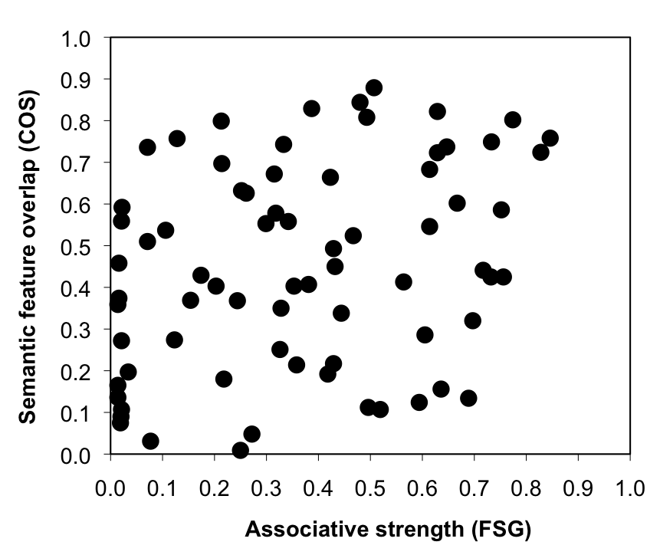

Figure 1

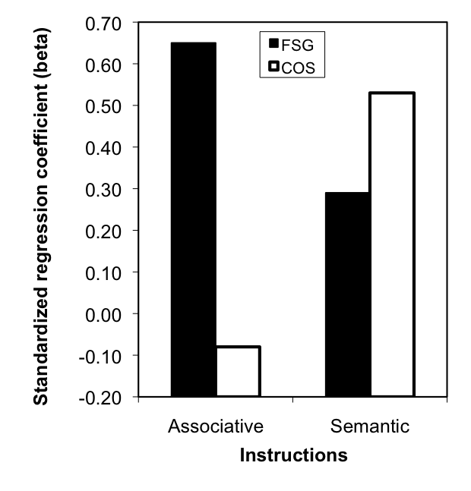 | 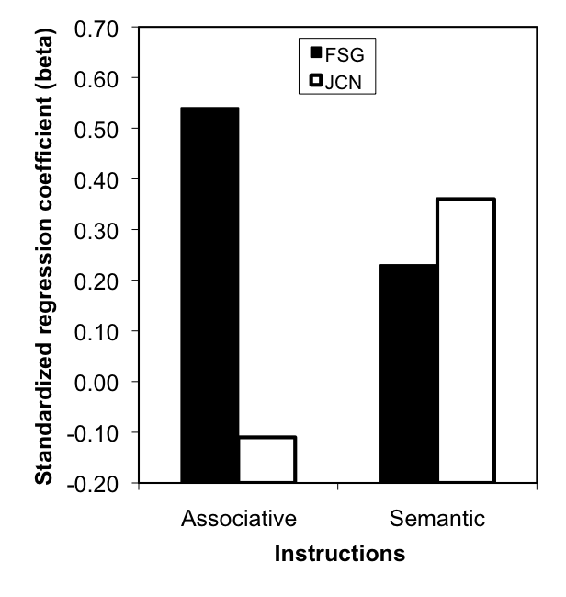

Figure 2

